**273/2**

**GEOGRAPHY**

**PAPER 2**

**2 ½ HRS**

**UGANDA CERTIFICATE OF EDUCATION**

**RESOURCEFUL MOCK EXAMINATIONS 2017**

**Uganda Certificate of Education**

GEOGRAPHY

**Paper 2**

2 hours 30 minutes

**INSTRUCTIONS TO CANDIDATES:**

*Answer* ***four***  *questions in all.*

*Choose* ***two*** *questions from part* ***I*** *and part* ***II.***

*In part* ***II****, only one question should be chosen from any* ***one*** *region.*

**PART I: THE REST OF AFRICA**

*(Answer* ***two*** *questions from this part)*

1. (a) Draw a sketch map of Africa and on it mark and name;
2. climatic regions: Savanna and Mediterranean.
3. Ocean currents :warm Guinea and warm Mozambique.
4. Winds :Hamattan and North East trade winds. *(07 marks)*

(b) Describe the characteristics of Savanna climate. *(05 marks)*

(c) Explain the factors that have led to the Savannah climate. *(06 marks)*

(d) outline the:

(i) economic activities carried out in Savanna regions in Africa. *(04 marks)*

(ii) problems faced by people living in the Sahel areas in Africa. *(04 marks)*

1. Study the table below showing sugar cane production from the Republic South Africa (1998 – 2003) and answer the questions that follow;

**Table 1: showing R.S.A sugar production between (1998 – 2003)**

|  |  |
| --- | --- |
| **Year** | **Sugar production in metric tons (‘000s)** |
| 1998  1999  2000  2001  2002  2003 | 1,230  1,140  1,470  1,540  1,170  1,000 |

***Adapted: 2005 Afr. Dev’t indicators.The World Bank Washington DC. Pg. 99***

1. Draw a line graph to represent the trend of sugar production from the Republic South Africa between 1998 and 2003 *(08 marks)*
2. Describe the trend of sugar production shown in (a) above. *(03 marks)*
3. Explain the conditions that have led to the trend of sugar production

shown in the graph. *(08 marks)*

1. Outline the problems faced by sugar producers in Africa. *(06 marks)*
2. (a) Draw a sketch map of the Gezira irrigation scheme and on it mark and name

the;

1. towns ; Khartoum, Kotsi and Wedi Medina
2. Dams : Sennar and Jebel Aulia
3. Irrigated areas; Gezira and Managil
4. The railway line from Khartoum to Kotsi. *(09 marks)*

(b) Describe the factors which have favoured the establishment of the Gezira

irrigation scheme. *(06 marks)*

(c) Explain the problems faced by the Gezira irrigation farmers as a result of establishment of the scheme. *(05 marks)*

(d) (i) Name any two crops grown on the Gezira scheme. *(02 marks)*

(ii) Outline the benefits of the irrigation farming to the people living

in dry lands of Africa. *(03 marks)*

1. Study the table below showing forest products exported from Swaziland (1990 – 1996) and answer the questions that follow;

**Table 2: forest products exported from Swaziland.**

|  |  |
| --- | --- |
| **Year** | **Forest products exports (M3)** |
| 1990  1991  1992  1993  1994  1995  1996 | 254,000  254,000  254,000  241,000  239,000  299,000  270,000 |

*Adapted: Africa Development Indicators (1997) The world bank, Washington DC. Pg. 89*

1. Draw a bar graph to represent the forest products exported from Swaziland. *(09 marks)*
2. Describe the trend of forest products exported from Swaziland between

1990 – 1996.  *(02 marks)*

1. (i) Name any two forest plantations in Swaziland. *(02 marks)*

(ii) Explain the factors that have favoured the establishment of forest plantations in Swaziland.  *(06 marks)*

1. (i) State any two forest products exported from Swaziland*. (02 marks)*

(ii) Outline the problems faced by countries exporting forest products in Africa.  *(06 marks)*

**PART II**

**STUDIES IN DEVELOPMENT**

**REGION I : NORTH AMERICA**

1. Study the table below showing the climatic statistics of station A in North America.

**Table 3: climatic statistics of station A; Altitude 56M**

|  |  |  |  |  |  |  |  |  |  |  |  |  |
| --- | --- | --- | --- | --- | --- | --- | --- | --- | --- | --- | --- | --- |
| **Month** | **J** | **F** | **M** | **A** | **M** | **J** | **J** | **A** | **S** | **O** | **N** | **D** |
| Temp 0C | -11 | -9 | -3 | 5 | 13 | 18 | 21 | 19 | 15 | 8 | 1 | -7 |
| R/F (mm) | 77 | 89 | 64 | 79 | 87 | 94 | 87 | 94 | 85 | 87 | 89 |  |

***Source: A course in world geography young and Lowy North America PG. 31, Fourth Edition***

1. Draw a suitable graph to show the information in the table.  *(09 marks)*
2. Calculate the;
3. mean annual temperature,
4. mean annual rainfall,
5. annual range of temperature of the station **A**. (*06 marks)*
6. Describe the characteristics of climate at station **A**.  *(05 marks)*
7. Explain the factors that influence the climate of North America*. (05 marks)*
8. Study the sketch map showing the main export routes for Canada wheat and answer the questions that follow;

**Main export routes for Canada Wheat.**

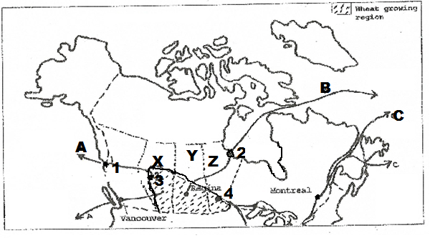

**Fig 3**

1. Name the;
2. Ports marked **1** and **2**
3. Provinces market **X**, **Y** and **Z**  *(05 marks)*
4. Outline the;
5. Disadvantages of transporting wheat along route **A**.  *(03 marks)*
6. Advantages of transporting wheat along route **C**.  *(03 marks)*
7. Describe the physical conditions that favour the growing of wheat in

Canadian Prairies. *(06 marks)*

1. (i) Explain the problems facing the wheat farmersin Canada. *(04 marks)*

(ii) Outlinethe steps being taken by Canadian government to solve the problems in (d) (i) above. *(04 marks)*

1. Study the table below showing total fish catch in Canada (1985 – 1995) and answer the questions that follow;

**Table 4; Canada: Total fish Catch; (‘000 metric tons)**

|  |  |
| --- | --- |
| **Year** | **Total fish catch** |
| 1985 – 87  1987 – 89  1989 – 91  1991 – 93  1993 – 95 | 1459.6  1571.2  1576.6  1324.9  1065.3 |

***Adapted from; World resources series (1990 – 99) A guide to the global environment: oxford, UNDP and the world bank.***

1. Draw a bar graph to show the information contained in the table. *(07 marks)*
2. Describe the trend of fish catch in Canada between1985 and 1995.

*(03 marks)*

1. Name any two;
2. fishing grounds found in Canada.
3. fishspecies caught in each of the fishing grounds named in (c) (i) above.

*(04 marks)*

1. Explain the;
2. conditions which have favoured fishing in any one fishing ground named in (c) (i) above.  *(06 marks)*
3. problems facing the fishing industry in any one fishing ground in Canada. *(05 marks)*

**REGION II : RHINELANDS**

1. Study the map of Switzerland provided below and answer the questions that follow;

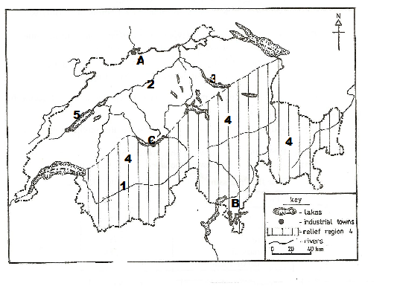

**Fig 3**

1. Name the;
2. rivers marked **1** and **2**
3. lakes marked **3** and **5**
4. relief region marked **4**
5. industrial towns marked **A**, **B** and **C**. *(08 marks)*
6. (i) State any two types of industries found in any one of the industrial

towns named in (a) (iv) above.

(ii) Describe the factors which have led to the location of industries in the towns marked in (a) (iv) above.  *(08 marks)*

1. Explain the problems facing the industrial sector in Switzerland. *(05 marks)*
2. Outline the steps being taken to promote the industrial sector in Switzerland.
3. *marks)*
4. (a) Draw a sketch map of the Rhine rift valley and on it, mark and name the:
5. rivers: Rhine and Neckar
6. Rhine rift valley.
7. Rhine gorge.
8. towns: Ludwigshafen and Frankfurt.
9. any two Vine growing areas. (9 marks)

(b) Describe the :

1. physicalconditions which have favoured vine growing in the Rhine rift valley.

(4marks)

1. activities carried out by the vine growers during spring and summer seasons.

(4marks)

(c ) Explain the problems faced by vine growers in the Rhine rift valley. (4 marks)

(d) Outline the measures being taken to solve them problems in (c) above.(4marks)

1. Study the table below showing the major cities of the Netherlands with their population sizes as of 2003 and answer the questions that follow;

***Table 6: Major cities of the Netherlands with their population as of 2003.***

|  |  |
| --- | --- |
| **City** | **Population** |
| Amsterdam  Rotterdam  The Hague  Utrecht  Eurdhoren | 1,536,000  1,133,200  699,300  610,000  201,300 |

***Source; htt/www. mongabay.cp,.gapo***

1. Draw a pie chart to represent the information in the table. *(10 marks)*
2. Describe the factors that have led to the high population size of Amsterdam City.

*(06 marks)*

1. Explain the functions of Amsterdam City.  *(04 marks)*
2. Outline the problems from a high population size facing Amsterdam city. *(04 marks)*

**REGION III : CHINA**

1. Study the table below showing the climate statistics of Canton in the R. Sikiang delta and answer the questions that follow;

**Table 7: climatic statistics of Canton in the R. Sikiang delta**

|  |  |  |  |  |  |  |  |  |  |  |  |  |
| --- | --- | --- | --- | --- | --- | --- | --- | --- | --- | --- | --- | --- |
| **Month** | **J** | **F** | **M** | **A** | **M** | **J** | **J** | **A** | **S** | **O** | **N** | **D** |
| Temp 0C | 13.3 | 13.9 | 17.2 | 21.7 | 26.7 | 27.2 | 28.3 | 26.7 | 23.9 | 19.4 | 15.6 | 14.0 |
| R/F (mm) | 23 | 48 | 107 | 173 | 269 | 269 | 205 | 219 | 165 | 86 | 31 | 23 |

1. Draw a suitable graph to show the climate of the station. *(09 marks)*
2. Describe the characteristics of the climate of R. Sikiang delta.*(06 marks)*
3. Describe the factors that influence the characteristics of the climate of R. Sikiang

delta. *(05 marks)*

1. Explain the influence of the climate on the development of Agriculture

in the River Sikiang Delta. *(05 marks)*

1. (a) Identify any two;
2. types of industries found in Beijing (Peking).
3. products manufactured from each of the industries identifies in (a) (i) above. *(04 marks)*

(b) Describe the conditions which have favoured the development of industries identified in (a) (i) above in Beijing.  *(08 marks)*

(c) Explain the;

(i) contributions of manufacturing industries to the people of China.  *(05 marks)*

(ii) problems as a result of the growth industrial sector on environment in

China.  *(05 marks)*

(d) Outline the measures being taken to solve the challenges in (c) (i) above.  *(03 marks)*

1. Study the mapof china showing population distribution and answer questions that follow.

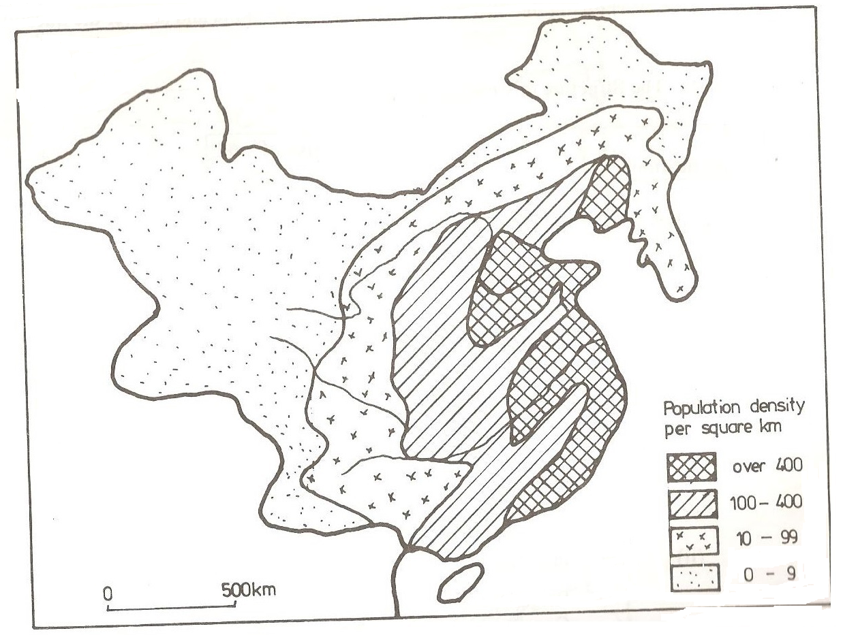

1. Name any two regions which are;
2. densely populated .
3. sparsely populated. *(4 marks)*
4. Describe the factors that have influenced population distribution in china.

(7marks)

1. Explain the effects of a large population size in china. *(8 marks)*
2. Outline the steps being taken by the government of china to solve the problems of a large population size. (6 marks)

**END**